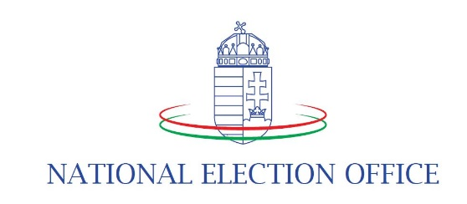

Media accreditation
for access to the election center

Details of the representative of the press (hereinafter referred to as the person concerned) entering the headquarters of the National Election Office as an election centre:

Name:

Nationality:
Name of media content provider:
personal identification number (or (or the number of the identity card or passport or driving licence issued by the Hungarian authorities):
Number of press card issued by a professional journalism organisation:
Phone number and email address:
If accreditation is granted on the basis of a proxy, the proxy issued by the media content provider to the person concerned must be attached.
As the person concerned, I declare that:
I understand the conditions of access for members of the press published by the National Election Office in connection with the 2024 Elections to the European Parliament, Municipal Elections and National Minority Elections

I have previously read the data processing information made available by the National Election Office as the data controller and I consent to the processing of my personal data in accordance with the terms and conditions set out therein.

Budapest, …………………………………….

……………………………..
signature

Please return the completed original form to one of the following contact details:

E-mail: akkred@nvi.hu
Postal address: National Election Office; 1397 Budapest, Pf.:547
Delivery in person: 1054 Budapest, Alkotmány u. 3.

The accreditation card can be collected on the day of the election.

